Title: Minutes of CISTC Meeting Held at GC 2014
Date/Time: 15:30 – 17:30, Tuesday, December 09th, 2014
Place: Colorado, 18th Floor, Hilton Garden Inn, Austin, Texas
Contact: Kejie Lu (kejie.lu@upr.edu)

1 Welcome / Introduction

The TC Chair, Dr. Yi Qian, Vice Chair for Conference, Dr. Kejie Lu, and Vice Chair for Publications, Dr. Xiaodong Lin attended the meeting. CISTC Secretary Dr. Francesco Chiti was not able to attend.

The meeting started at 15:00pm in Colorado Room, 18th Floor, Hilton Garden Inn, Austin, Texas. The total number of attendees was 40 (the complete list is given in Appendix I).

The TC Chair, Dr. Yi Qian, addressed the meeting by welcoming all the audience and asked every attendee to introduce himself/herself. He then briefly introduced the current TC officers listed below
- Chair: Yi Qian
- Vice Chair on Conferences: Kejie Lu
- Vice Chair on Publications: Xiaodong Lin
- Secretary: Francesco Chiti
- CISTC representative for IEEE ComSoc Standards Board: Neeli R. Prasad
- CISTC representative for IEEE COMSOC Student Competition Committee: Kai Zheng
- Award Chair: Peter Mueller

He then gave update about the TC
- Currently has two mail distribution lists including
  - cistc@comsoc.org
TC internal announcements
ICC, Globecom, CNS
Annual meetings (2 per year)
Awards
  - cistc-distribution@comsoc.org
CFP ditribution
Open to all signed-up members to distribute CIS-TC related CFPs
The only difference between two mail distribution lists is that cistc-distribution@comsoc.org is an open list, while cistc@comsoc.org is reserved for CIS-TC internal announcements
- The TC website: http://committees.comsoc.org/cistc/

2. Approval of the Agenda

The agenda of the CISTC meeting was approved unanimously by the attendees.

3. Approval of Meeting Minutes ICC 2014 (Sidney)

The minutes of the meeting can be found in the TC website:
http://cms.comsoc.org/SiteGen/Uploads/Public/Docs_TC_CIS/CISTC_Meeting_ICC_2014_Minutes.pdf

Alternatively, one can visit the TC website and then click on the link of “Meetings” to the
left of the page:
http://committees.comsoc.org/cistc

The minutes of the CISTC meeting at ICC 2014 was approved as posted by the attendees.

4. CISTC Newsletters

As the editor of CISTC newsletter, Dr. Kejie Lu introduced the CISTC newsletters. The proposal approved in the last CISTC meeting can be found in
http://cms.comsoc.org/eprise/main/SiteGen/TC_CIS/Content/Home/Meetings.html
http://cms.comsoc.org/SiteGen/Uploads/Public/Docs_TC_CIS/CISTC_newsletter_proposal.pdf

The first issue of the CISTC newsletter was posted on November 22, 2014, with the following content:
- CISTC Meeting: 1 (CISTC meeting in GC 2014)
- Job Openings: 5
- CISTC Main Conferences: 3
- CISTC Endorsed Conferences: 4
- Conference Call for Paper: 8
- Conference Call for Participation: 2
- New Books: 2
- Journal / Magazine Special Issues: 2

Finally, Dr. Kejie Lu explained that the second issue of the newsletter shall be posted in January 2015, and he also discussed future improvement for the newsletter, including an editorial board and adding feature topics into the newsletter.

5. CIS-TC Outstanding Service Award

Award Chair and the former CISTC Chair, Dr. Peter Mueller gave an update on CIS-TC Service Award. He explained the nomination policy and process, which can be found on CIS-TC website. The Committee has decided not to give this award this year since we do not have a suitable candidate.

6. Reports on Conferences

Dr. Kejie Lu, the TC Vice-Chair for Conference, gave an overview on conference activities in CIS-TC. CIS-TC endorsed the largest number of conferences among the other ComSoc TCs.

Specifically, Dr. Kejie Lu further presented some information about the future Globecom and ICC conferences. He also emphasized that every active CIS-TC members can be nominated for Communications and Information Systems Security (CISS) Symposium chairs. An active CIS-TC member should be actively involved in TC activities, and at least attend twice CIS-TC meetings in the past two years.

The detailed information about the conferences that have been organized during the foregoing year can be found in Appendix III. Also, detailed information about CIS-TC endorsed conferences can also be found in Appendix III.

Furthermore, Dr. Kejie Lu reiterated TC Endorsement procedure, which requires at least three TC members to endorse and support the conference requesting the endorsement.

In the end, Dr. Guoliang (Larry) Xue gave an update on IEEE Conference on Communications and Network Security (CNS), the only security conference sponsored by ComSoc. As the only IEEE ComSoc Conference solely focusing on security, IEEE CNS is part of ComSoc Core Conference Portfolio. It is a spin-off of IEEE INFOCOM, positioned to be a top security conference. Peer targets include ACM CCS, IEEE S&P, USENIX Security, and NDSS.

Afterwards, Dr. Guoliang Xue presented reports about the second IEEE CNS, including acceptance rate, the number of submissions, the number of attendees, and geographic distribution of authors and papers. Finally, he introduced IEEE CNS 2015.

7. Reports on Publications

Dr. Xiaodong Lin, the TC Vice-Chair for Publications, presented a report on the publication activities supported by the committee.

In the past year, CISTC members have contributed a lot and participated in many books (7 in total) and special issues (11 in total). He also mentioned some books in preparation (2 in total) and upcoming special issues (3 in total). Please refer to Appendix IV for the complete list of books and special issues.

Finally, Dr. Peter Mueller introduced the status of a new magazine under ComSoc about cyber security. Specifically, IEEE Communications Magazine has agreed to assign 4 slots for feature topics on security issues in the next year. (Peter: please explain more details)

8. Standards liaison

CIS-TC representative for IEEE ComSoc Standards Board, Dr. Neeli R. Prasad, provided a brief verbal summary of standard activities.

9. Next CIS-TC Meeting

The next IEEE ComSoc’s Communication & Information Security TC (CIS-TC) meeting will be held at IEEE ICC 2015, London, UK.

10. Adjourn

Dr. Yi Qian thanked all the people who attended this TC meeting, and thanked all the CISTC members who contributed to the success of CISTC. The meeting ended around 4:10 pm.

(December, 2014)

Appendix I
The total 40 committee members attended the meeting. (Francesco: please help to fill the table)
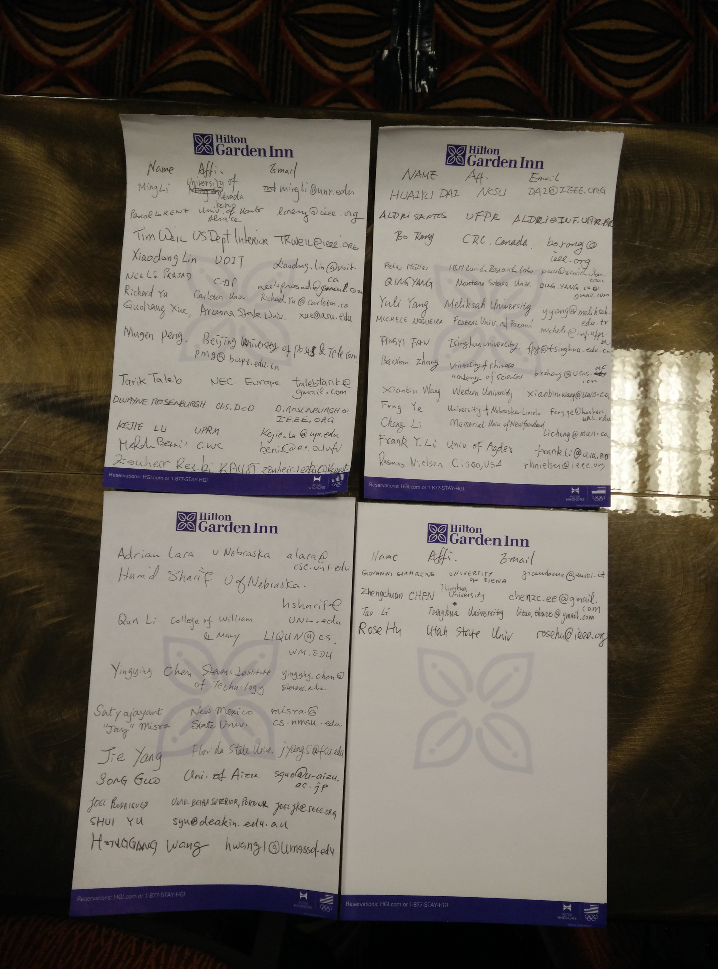

Appendix II

CIS-TC Technical Recognition Award

This page Intentionally Left Blank
Appendix III

Conference | Submitted | Accepted | Reviews | TPC | Representatives
CISTC Organized Conferences
GC’14, November 16 -20, 2014  Austin, TX, USA | 110 | 44 | >=3 | 138 | Xiaodong Lin  Jun Li  Dwayne Rosenburgh
ICC’15, June 7-11, 2015  London, UK | 163 | TBD | >=3 | 255 | Xiaojiang Du  Raheem Beyah  Xiaoyan Zhu
GC’15, December 6 -10, 2015  San Diego, California | TBD | TBD | TBD | TBD | Peter Muller  Yang Yang
IEEE CNS 2014  October 29 ~31, 2014  San Francisco, USA | 130+ | 38 | >=3 | 66 TPCs + 10 Area Chairs | Cliff Wang, Army Research Office  Guoliang "Larry" Xue, Arizona State University
CISTC Endorsed Conferences
SPECTS 2014  July 6-10, 2014, Monterey, CA, USA  http://atc.udg.edu/SPECTS2014/ |  |  |  |  | Floriano De Rango  Lei Shu  Mohammad S. Obaidat
ITC 2014  http://www.itc26.org/ |  |  |  |  | Jun Cai  Deep Medhi  Victor Yu Liu
ICCCT 2014  http://mnnit.ac.in/iccct2014/ |  |  |  |  | Krishn Mishra  Rajeev Tripathi  Sandeep Harit  Peter Muller
WTC 2015  http://www.csupomona.edu/wtsi |  |  |  |  | Steven Powell, General Chair  Thomas Ketseoglou, WTS Assistant Chair  Qing-An Zeng, Proceedings Chair; Review Process Chair
ICNC 2015 (Communications and Information Security Symposium)  http://www.conf-icnc.org/2015/ |  |  |  |  | Xinwen Fu, University of Massachusetts Lowell, USA, Email: xinwenfu@cs.uml.edu  Shui Yu, Deakin University, Australia, Email: syu@deakin.edu.au  Rongxing Lu, Nanyang Technological University, Singapore, Email: rxlu@ntu.edu.sg
DRCN 2015 (International Conference on Design of Reliable Communication Networks)  http://www.drcn2015.org/ |  |  |  |  | Byrav Ramamurthy, University of Nebraska-Lincoln, USA; byrav@cse.unl.edu  Nelson L. S. da Fonseca, State University of Campinas, Brazil; nfonseca@ic.unicamp.br  Yi Qian, University of Nebraska-Lincoln, USA; yqian2@unl.edu
ICCCN 2015 (The 24th International Conference on Computer Communications and Networks)  http://icccn.flair-solution.com/ |  |  |  |  | Yi Qian, University of Nebraska-Lincoln, USA; email: yqian2@unl.edu  Honggang Wang, University of Massachusetts Dartmouth, USA; hwang1@umassd.edu  Min Song, Michigan Tech University, USA; mins@mtu.edu

Appendix IV

(Xiaodong: Please help to update the table below)

Journal special issues
special issue Topic | Publisher/Journal | Editors
Books
Book title | Publisher | Authors/ Editors
Books in Preparation
Upcoming Journal special issues
Ideas About Feature Topics

